**## Mission 1**

**\*\*Issue\*\***: Due to the DoS attack, the Empire took down the Resistance's DNS and primary email servers.

- The Resistance's network team was able to build and deploy a new DNS server and mail server.

- The new primary mail server is `asltx.l.google.com` and the secondary should be `asltx.2.google.com`.

- The Resistance (starwars.com) is able to send emails but unable to receive any.

Your mission:

- Determine and document the mail servers for starwars.com using NSLOOKUP.

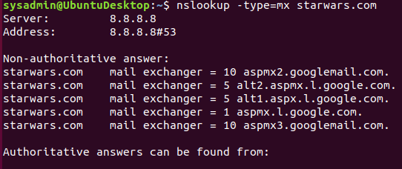

- Explain why the Resistance isn't receiving any emails.

They are not receiving any emails becuase their MX record is not set to the new primary and secondary email servers.

- Document what a corrected DNS record should be.

Starwars.com mail exchanger = 1 asltx.1.google.com

Starwars.com mail exchanger = 5 astlx.2.google.com

**### Mission 2**

**\*\*Issue\*\***: Now that you've addressed the mail servers, all emails are coming through. However, users are still reporting that they haven't received mail from the `theforce.net` alert bulletins.

- Many of the alert bulletins are being blocked or going into spam folders.

- This is probably due to the fact that `theforce.net` changed the IP address of their mail server to `45.23.176.21` while your network was down.

- These alerts are critical to identify pending attacks from the Empire.

Your mission:

- Determine and document the `SPF` for `theforce.net` using NSLOOKUP.

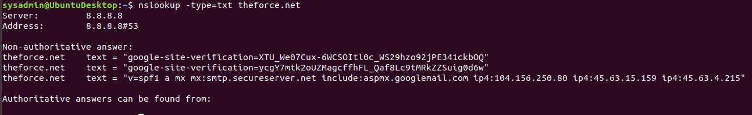

- Explain why the Force's emails are going to spam.

Seems like the force hasnt updated their DNS record to the required SPF to the new mail server.

- Document what a corrected DNS record should be.

theforce.net text = "v=spf1 a mx mx:smtp.secureserver.net

include:aspmx.googlemail.com include: ip4:45.23.176.21

ip4:104.156.250.80 ip4:45.63.15.159ip4:45.63.4.215"

**### Mission 3**

**\*\*Issue\*\***: You have successfully resolved all email issues and the resistance can now receive alert bulletins. However, the Resistance is unable to easily read the details of alert bulletins online.

- They are supposed to be automatically redirected from their sub page of `resistance.theforce.net` to `theforce.net`.

Your mission:

- Document how a CNAME should look by viewing the CNAME of `www.theforce.net` using NSLOOKUP.

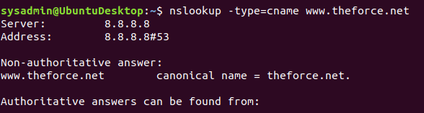

- Explain why the sub page of `resistance.theforce.net` isn't redirecting to `theforce.net`.

The Cname record does not contain a reference of

resistance.theforce.net to redirect to theforce.net

- Document what a corrected DNS record should be.

www.theforce.net canonical name = theforce.net.

resistance.theforce.net canonical name = www.theforce.net.

**### Mission 4**

**\*\*Issue\*\***: During the attack, it was determined that the Empire also took down the primary DNS server of `princessleia.site`.

- Fortunately, the DNS server for `princessleia.site` is backed up and functioning.

- However, the Resistance was unable to access this important site during the attacks and now they need you to prevent this from happening again.

- The Resistance's networking team provided you with a backup DNS server of: `ns2.galaxybackup.com`.

Your mission:

- Confirm the DNS records for `princessleia.site`.

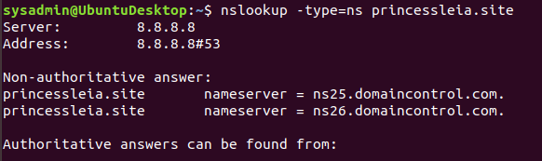

- Document how you would fix the DNS record to prevent this issue from happening again.

Add a reference to the backup DNS server:

princessleia.site nameserver = ns25.domaincontrol.com

Princessleia.site nameserver = ns26.domaincontrol.com

princessleia.site nameserver = ns2.galaxybackup.com

**### Mission 5**

**\*\*Issue\*\***: The network traffic from the planet of `Batuu` to the planet of `Jedha` is very slow.

- You have been provided a network map with a list of planets connected between `Batuu` and `Jedha`.

- It has been determined that the slowness is due to the Empire attacking `Planet N`.

Your Mission:

- View the [Galaxy Network Map](resources/Galaxy_Network_map.png) and determine the `OSPF` shortest path from `Batuu` to `Jedha`.

- Batu D C E F J I L Q T V Jedha - 23 steps

- Confirm your path doesn't include `Planet N` in its route.

Batu D C E F J I L Q T V Jedha

- Document this shortest path so it can be used by the Resistance to develop a static route to improve the traffic.

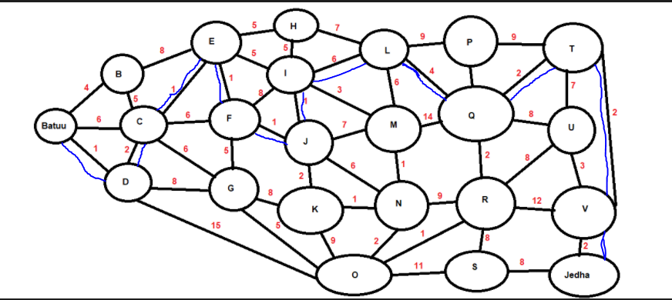

**### Mission 6**

**\*\*Issue:\*\*** Due to all these attacks, the Resistance is determined to seek revenge for the damage the Empire has caused.

- You are tasked with gathering secret information from the Dark Side network servers that can be used to launch network attacks against the Empire.

- You have captured some of the Dark Side's encrypted wireless internet traffic in the following pcap: [Darkside.pcap](resources/Darkside.pcap).

Your Mission:

- Figure out the Dark Side's secret wireless key by using Aircrack-ng.

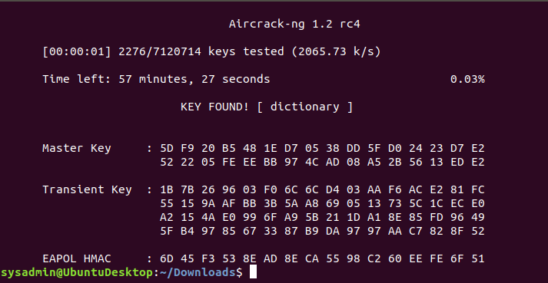

- Hint: This is a more challenging encrypted wireless traffic using WPA.

- In order to decrypt, you will need to use a wordlist (-w) such as `rockyou.txt`.

- Use the Dark Side's key to decrypt the wireless traffic in Wireshark.

- Hint: The format for they key to decrypt wireless is `<Wireless_key>:<SSID>`.

- Once you have decrypted the traffic, figure out the following Dark Side information:

- Host IP Addresses and MAC Addresses by looking at the decrypted `ARP` traffic.

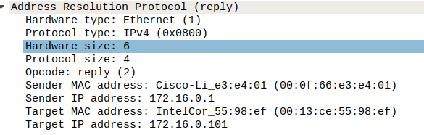

- Document these IP and MAC Addresses, as the resistance will use these IP addresses to launch a retaliatory attack.

Target: 172.16.0.101 is at 00:13:ce:55:98:ef

Sender: 172.16.0.1 is at 00:0f:66:e3:e4:01

**### Mission 7**

As a thank you for saving the galaxy, the Resistance wants to send you a secret message!

Your Mission:

- View the DNS record from Mission #4.

- The Resistance provided you with a hidden message in the `TXT` record, with several steps to follow.

- Follow the steps from the `TXT` record.

- **\*\*Note\*\***: A backup option is provided in the TXT record (as a website) in case the main telnet site is unavailable

- Take a screen shot of the results.

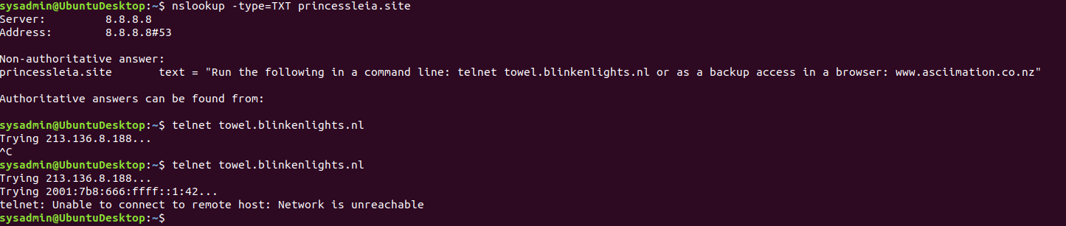



**### Conclusion**

- Submit your results and findings from every mission.

- Congratulations, you have completed your mission and saved the Galaxy!